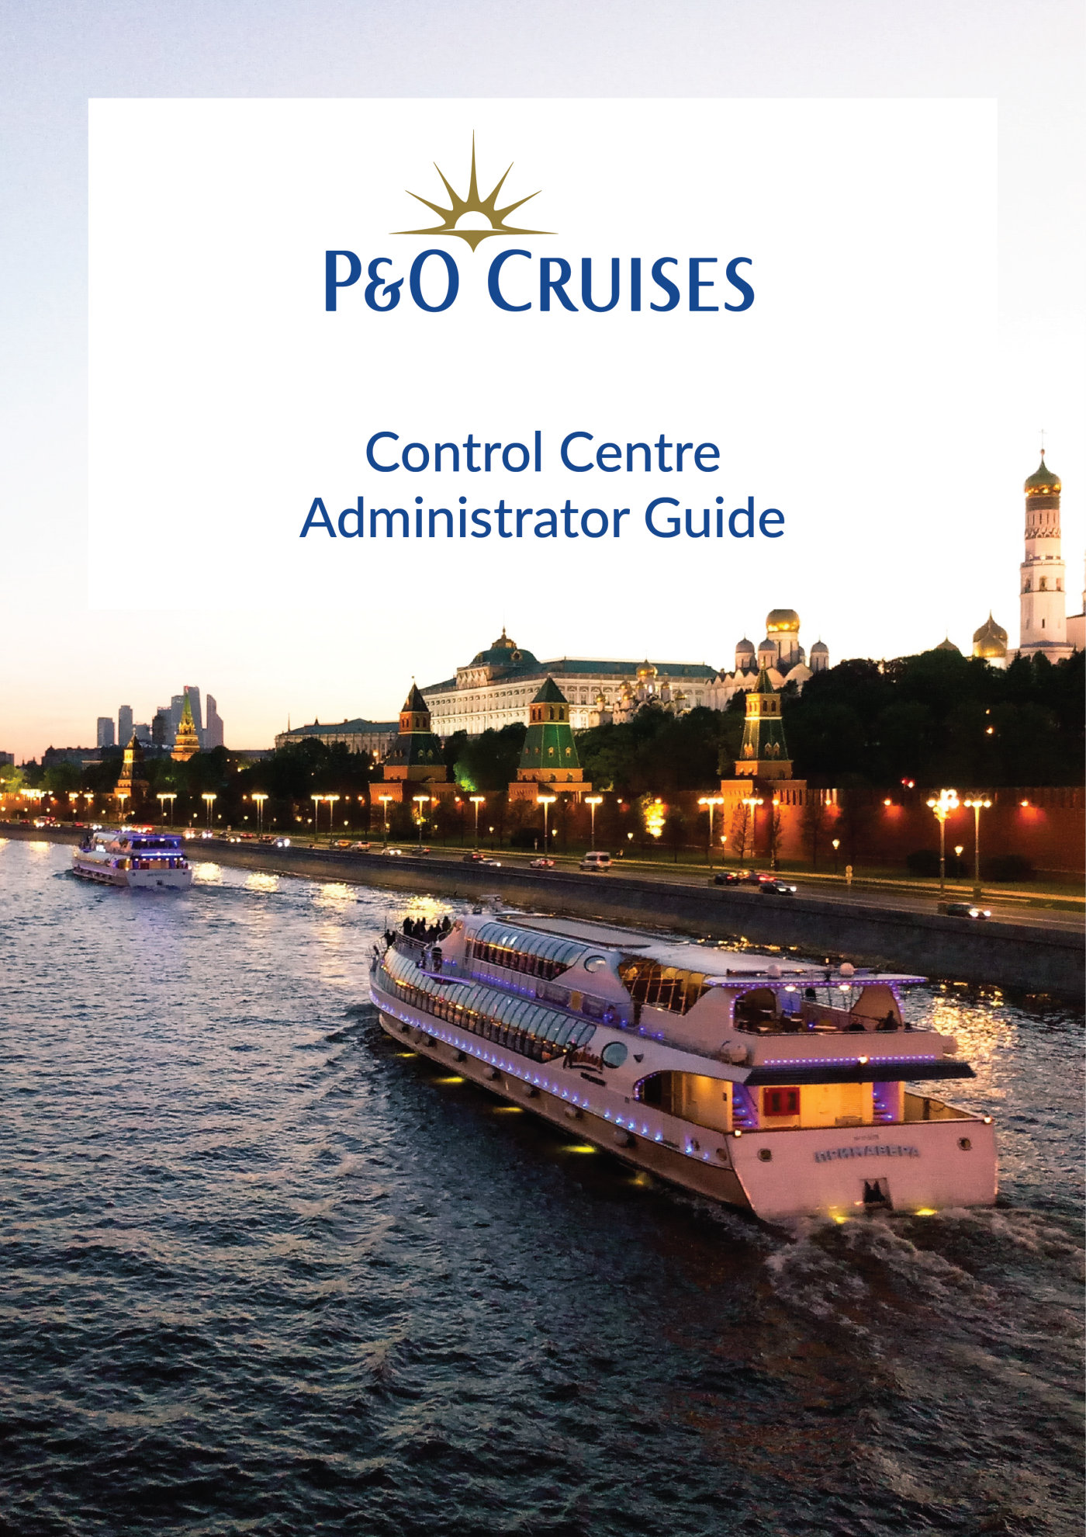

**Control Centre Module**

Ship side application to enable business users to carry out back office operations including manual syncing of AEM master content/images, carousel and banner images.

Table of Contents

**1. Login Page 4**

**2. Package Import 5**

**3. Carousel & Banner Import 7**

**4. Users 10**

**5. Reset Password 11**

**6. App Kisosk Settings 12**

# 

# 1. Login Page

You can use the Login screen to enter the appropriate email address and password to login.

If you forgot your password, enter your email address and use "**Forgot Password?**" link to recover the password.

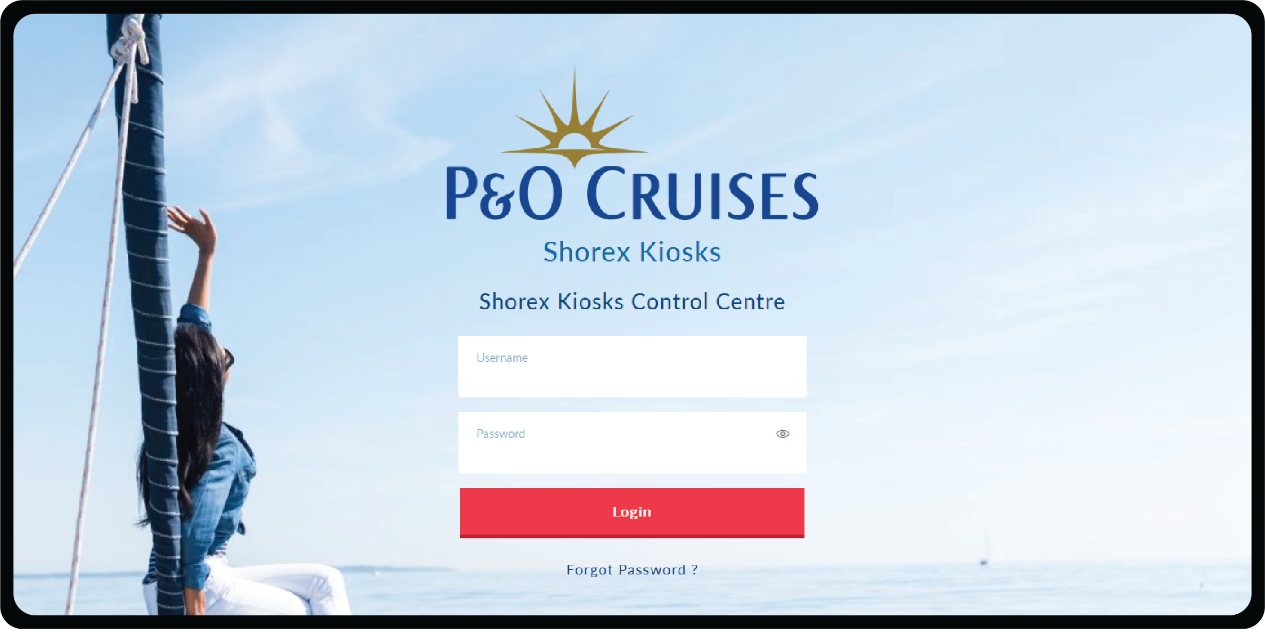

# 2. Package Import

You can perform the following actions on this page.

**Add Import Package:** You can click on **+IMPORT PACKAGE** to upload Text and Image package to Control Centre.

Admin has the option to replace the imported package with any of the latest 3 package using **Rollback** functionality.

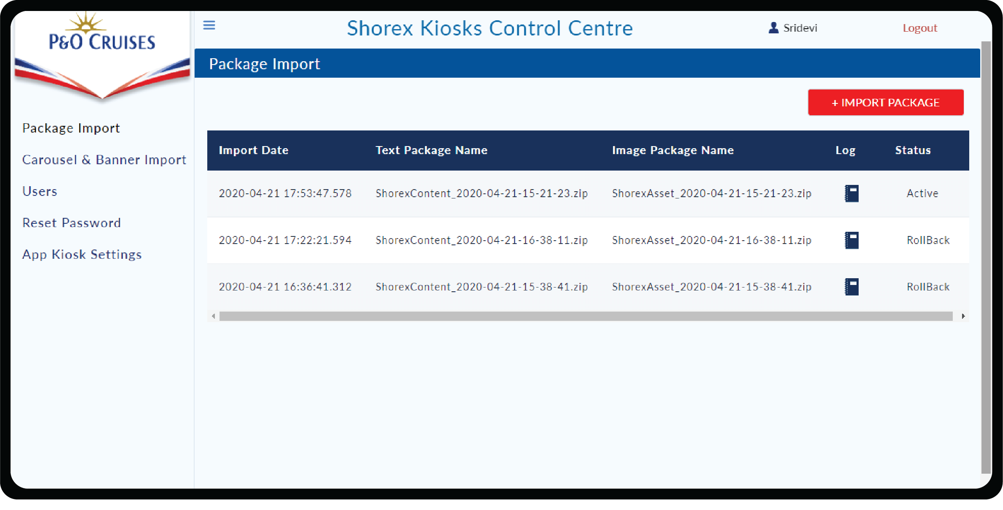

Click on **Upload** File button **or drag and drop** the text and image package and click on **Install Package** button. After successful import, there will be a new entry in **Import Package** table.

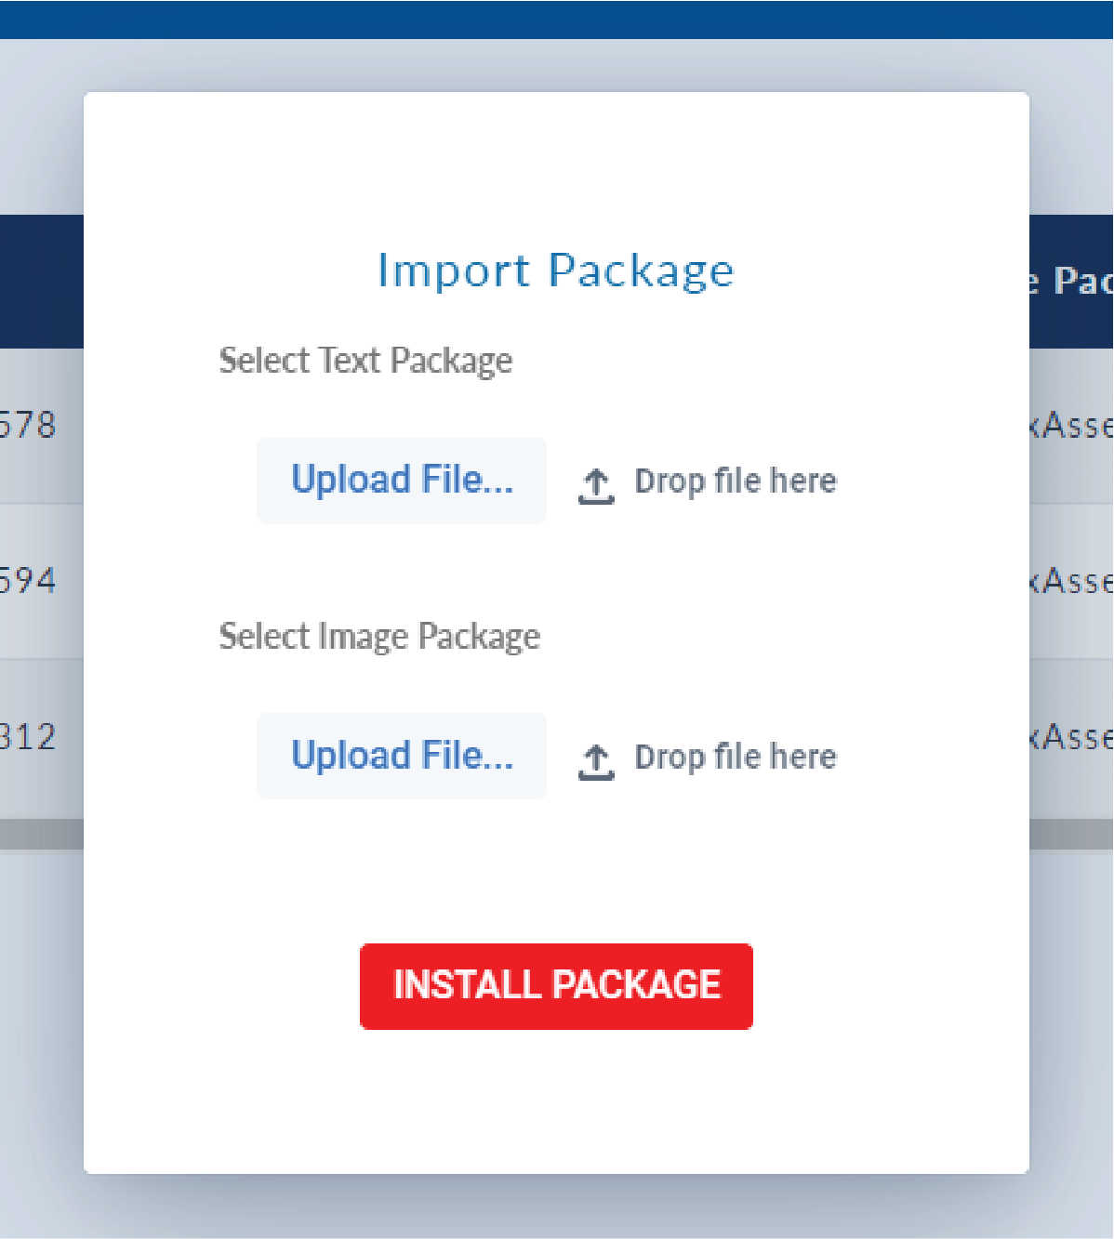

**View Log:** View Log can be used to view the attribute changes for each of each of the excursion for a particular import history.

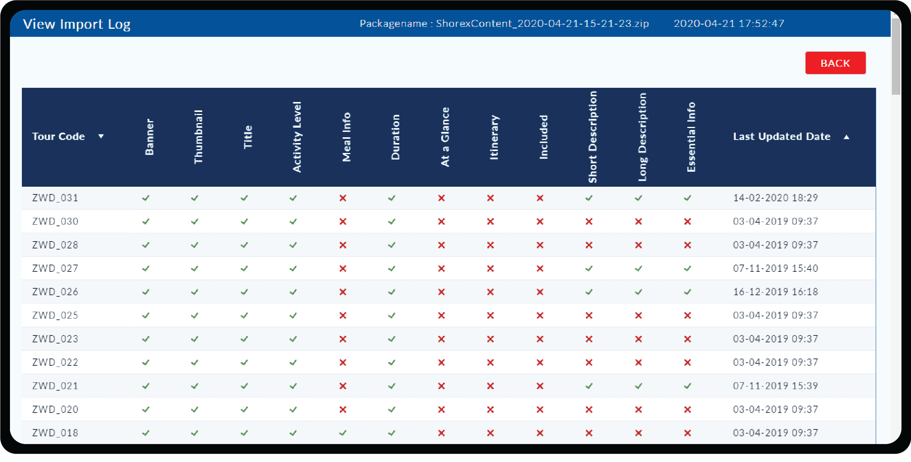

# 3. Carousel & Banner Import

This page is for managing the Carousel Images and Banner Images.

Images uploaded in the table have to maintain a particular size **(1824x1830px)** to contain.

To delete the unwanted images from the table click on **Delete** icon.

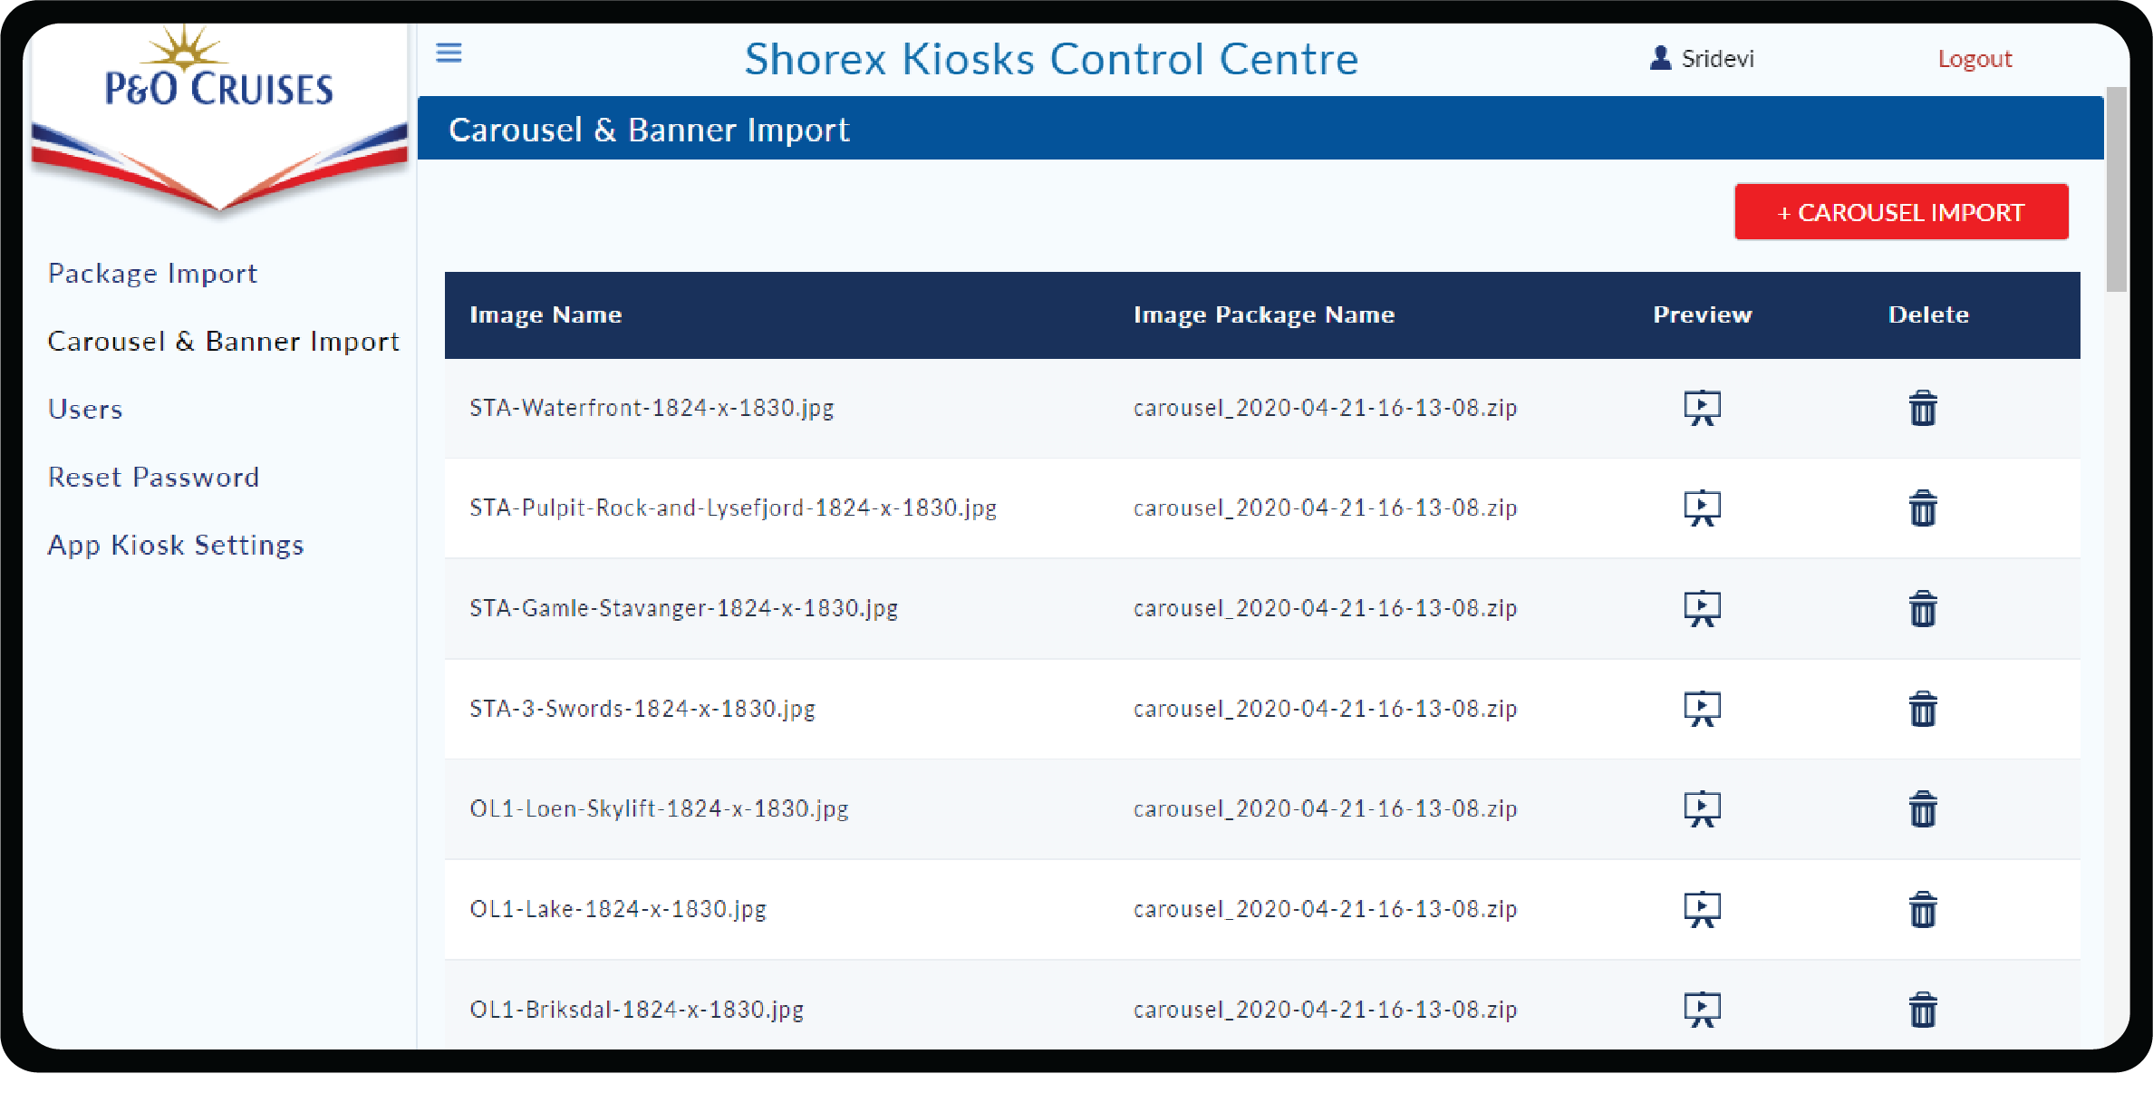

**Import Carousel Package:** You can click on **+CAROUSEL IMPORT** to upload Carousel package to Control Centre by clicking **Upload File** button or **drag and drop method** and click on **Install Package** button.

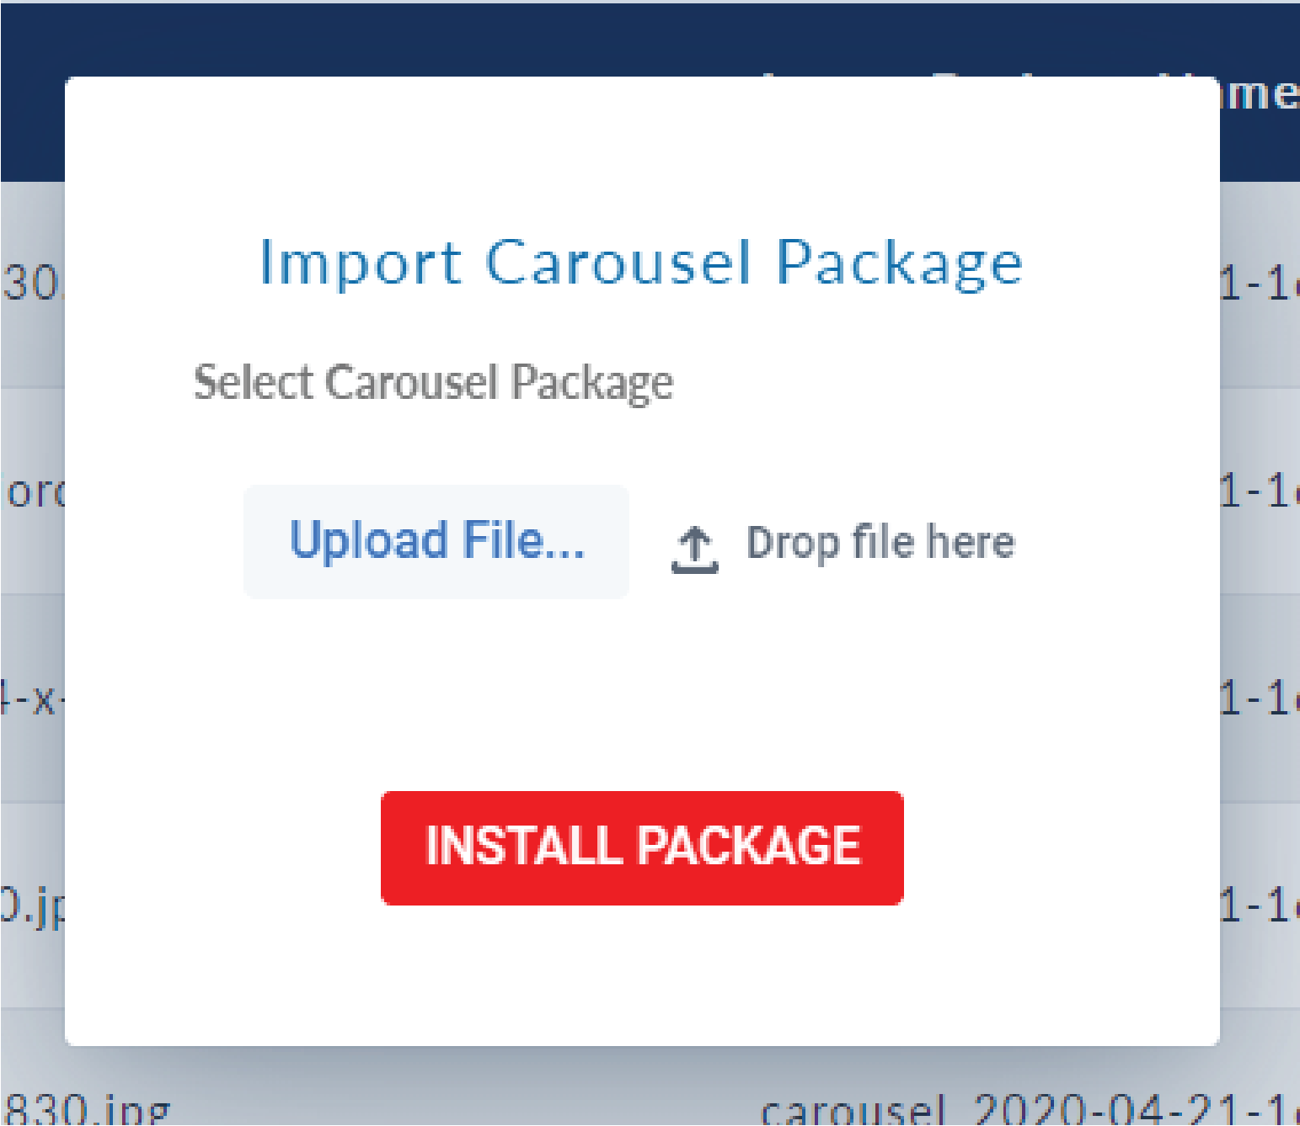

**Import Banner Package:** You can click on **+BANNER IMPORT** to upload Banner package to Control Centre by clicking **Upload File** button or **drag and drop method** and click on **Install Package** button.

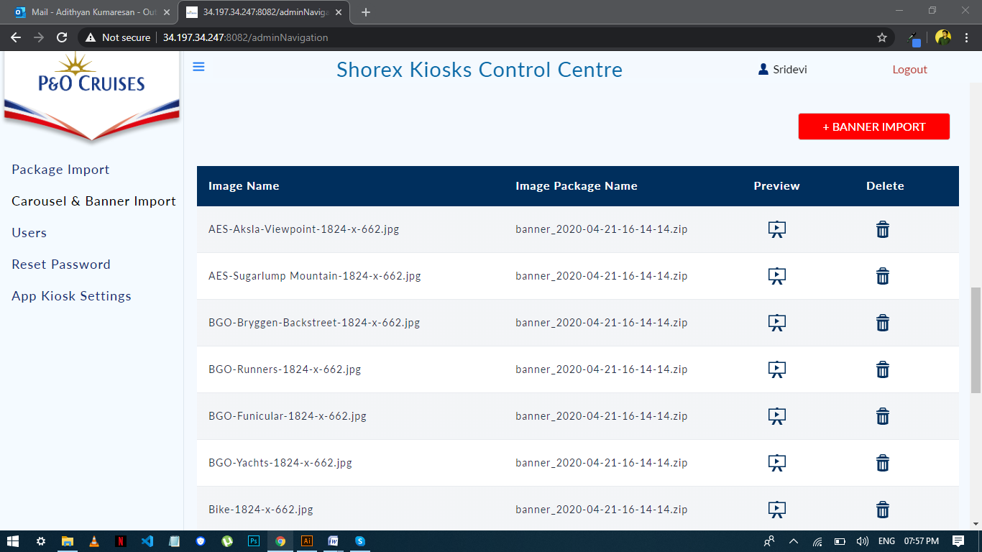

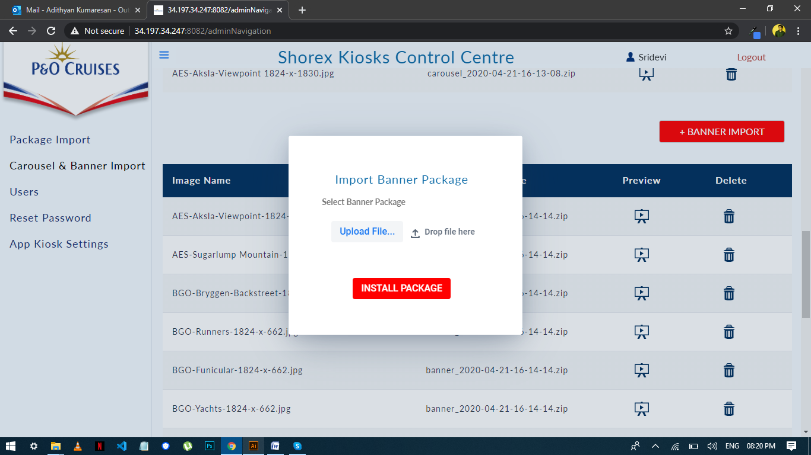

**Preview icon** is used to preview the uploaded image and can be closed by clicking outside the image after viewing.

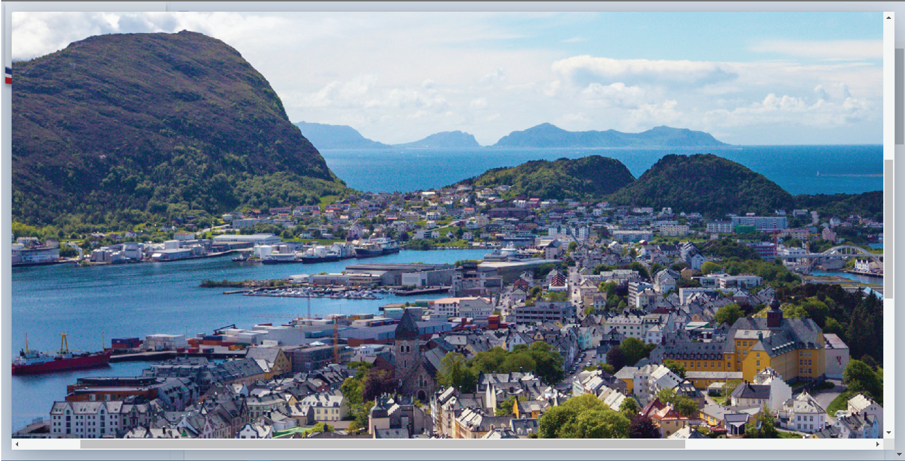

4. Users

You can perform the following actions

**Add:** Add a new user to the application click **+NEW USER** Button and **Submit** upon filling the details.

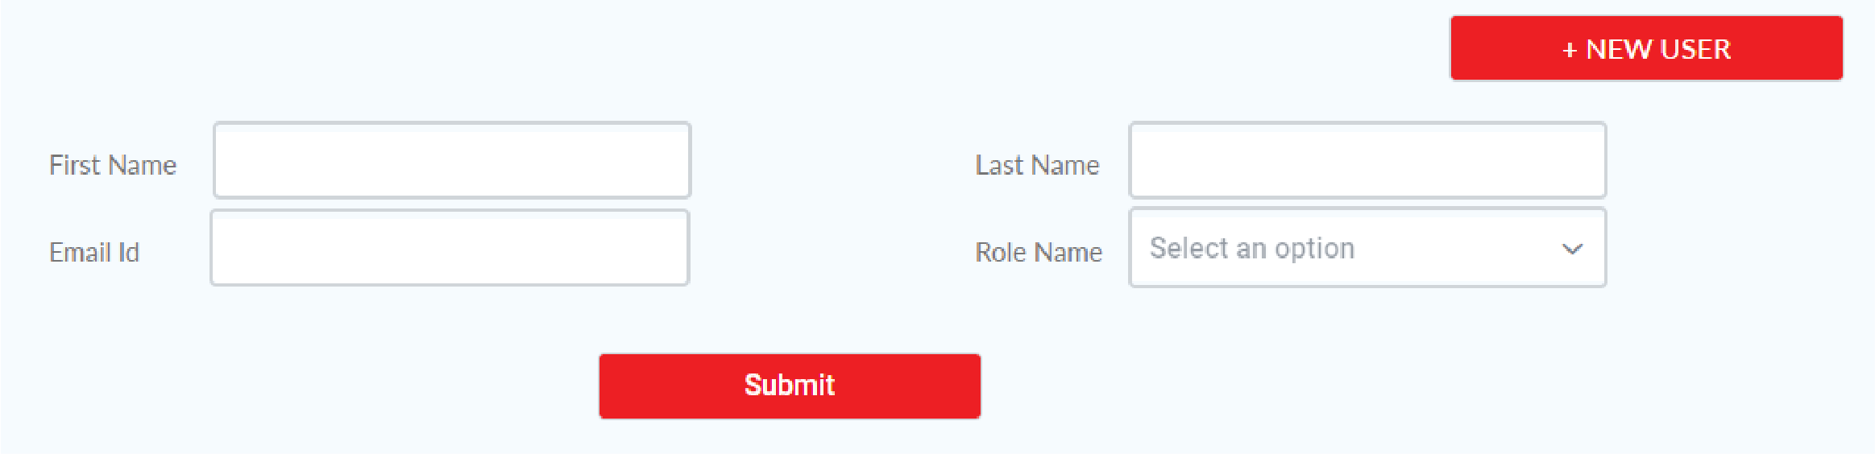

**Edit:** Edit an existing user by clicking the Edit Icon to change your First and Last name only.

**Delete:** Delete a user from the distribution list by clicking the Delete Icon.

Logged in Admin cannot delete themselves and also cannot Edit/Delete SuperAdmin user.

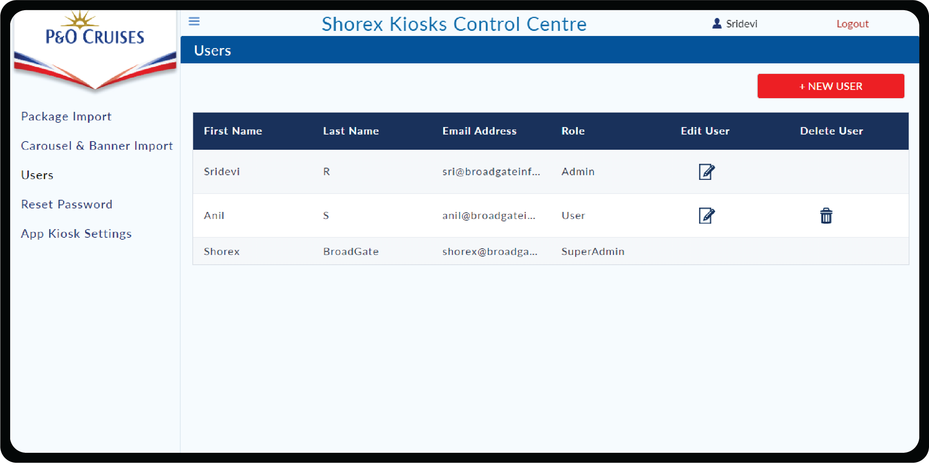

# 5. Reset Password

Reset Password, facilitates the logged on user to change the password.

In order to reset, you need to enter Current Password, New Password and Confirm Password and click Reset button. You can login with new password during the next login.

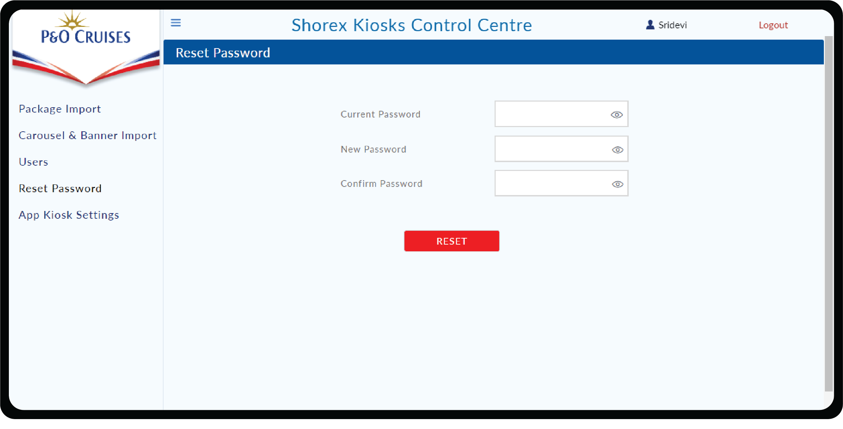

# 6. App Kisosk Settings

You can perform the following actions

App Kiosk Setting allows you to change Language preference and Booking Cut-off time according to our convenience.

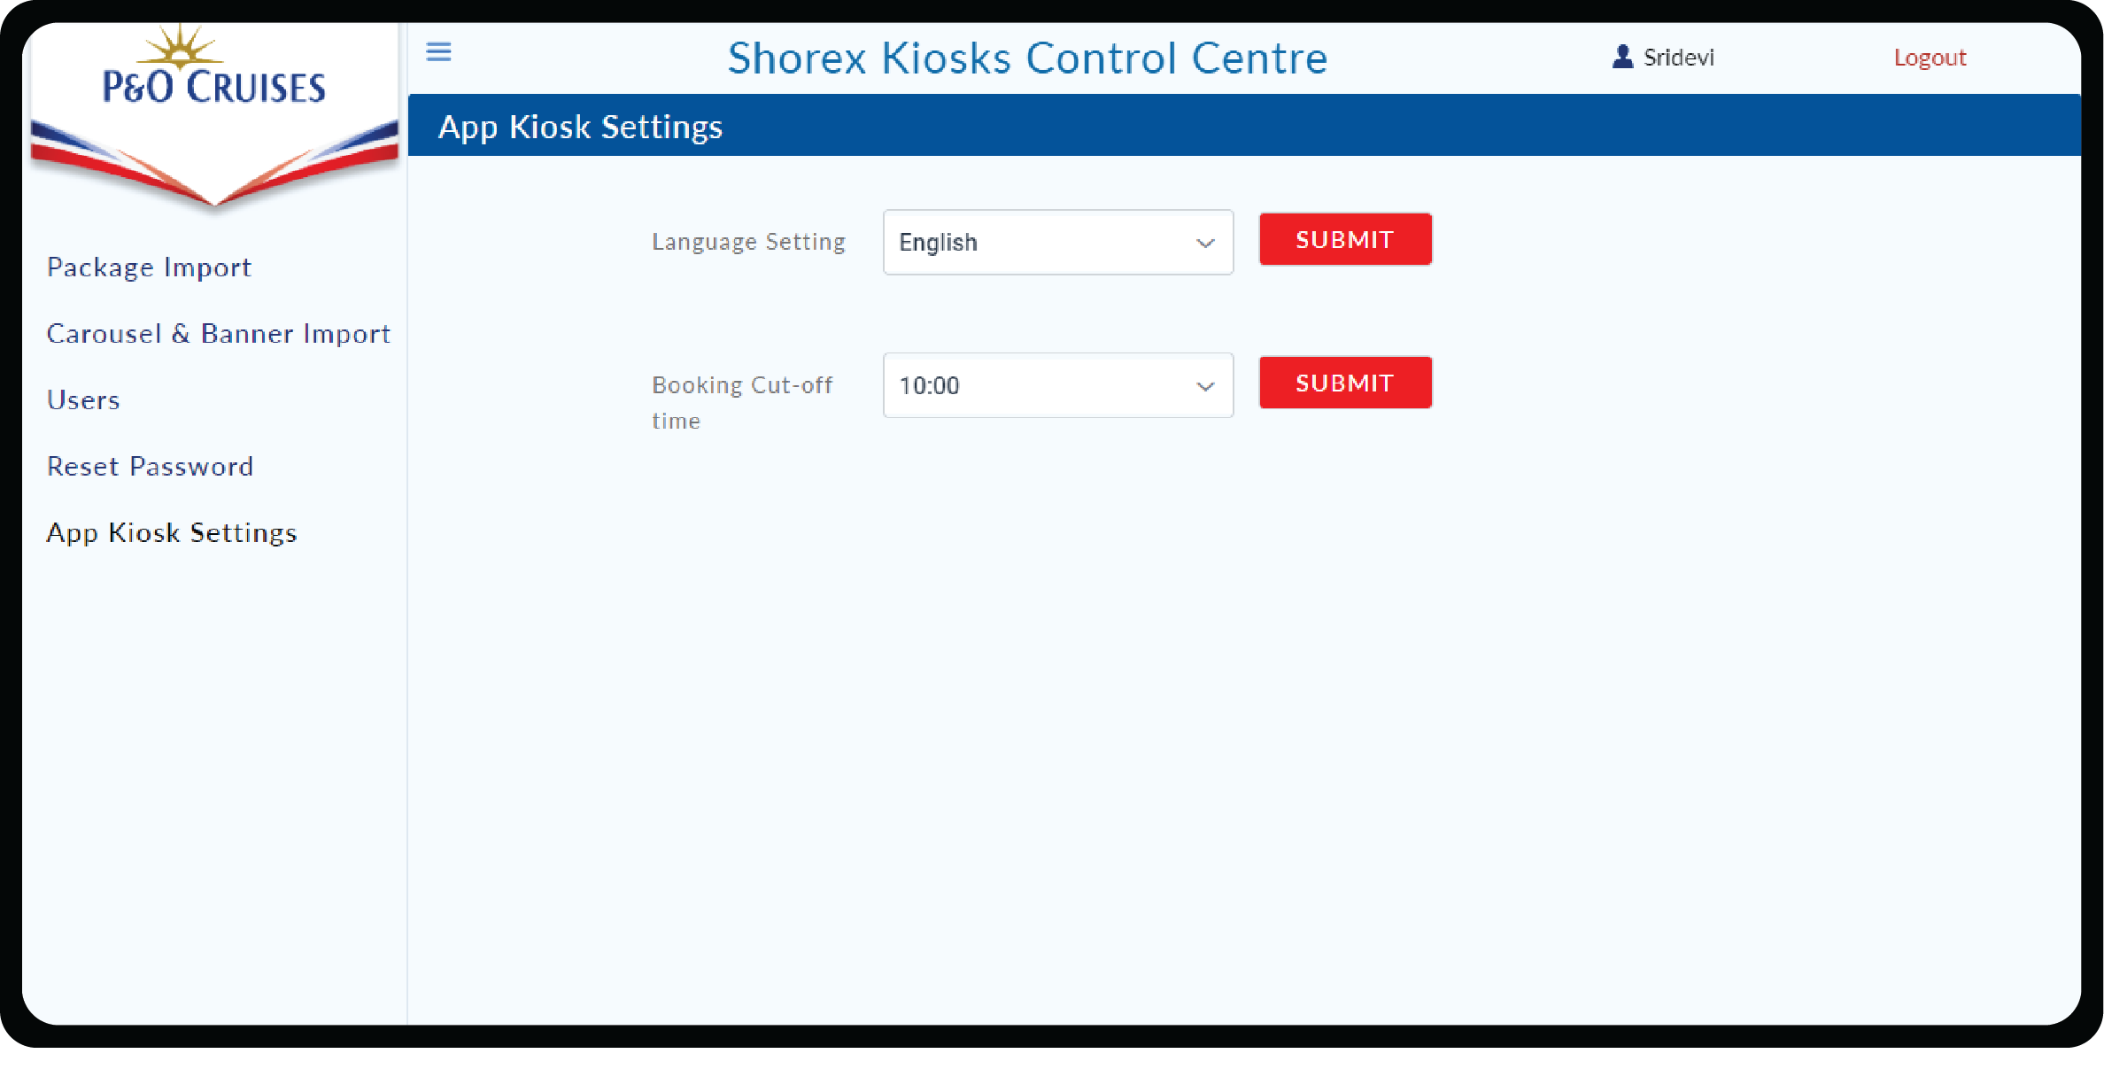

By clicking on **Language setting** text box you get to choose other available language where you can select from that and click on **Submit** button.

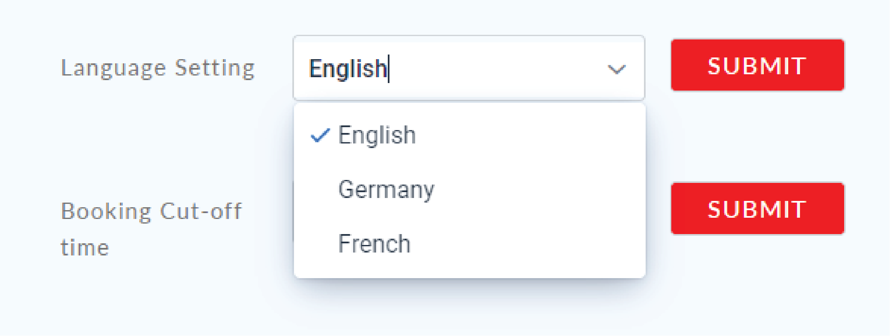

By clicking on **Booking Cut-off time** text box you get to choose your required time where you can select from that and click on **Submit** button.

